## **Effects of whole body vibration using the Vibrant Health Power 1000 in retrospective observational survey**

**Becky Chambers, BS, MEd., Jaswant Chaddha, MD, FACOG**

**Abstract**

Whole Body Vibration (WBV) has been shown to be beneficial in improving health and maintenance of health in the general population. WBV has also been beneficial in improving disabilities in patients in hospitals and nursing homes. Currently a wide range of types of WBV machines and suggested methods of use are available in this country with variable results. The purpose of this Retrospective Observational study is to assess the benefits of relatively gentle, vertical vibration, using Ms Chambers’ slow and careful method, for relatively healthy people who want to improve quality of life health issues (i.e. strength, energy level, mobility, sleep, mood/anxiety level, and pain levels).

A HIPPA compliant survey was designed and administered by email through Survey Monkey. The survey was sent on March 11, 2019 to 187 customers over the past two years of the Vibrant Health Power 1000 (VH Power 1000) vibration machine, which delivers relatively gentle, vertical vibration. No monetary compensation was offered. Of 187 surveys, a total of 53 (28.3%) customers responded, 52 within 6 days. The survey was closed after 2 weeks. A variety of question types were included: multiple choice, yes/no, comment boxes, Likert scales (1-10) for pain assessments, and analog scales 1-5 for other characteristics investigated.

We observed rapid improvements in strength, energy level, mobility, sleep, mood/anxiety, and pain levels, particularly joint pain, lower back pain, and muscle pain. Weight loss, and increases in bone density were also reported. Clinical trials are needed in all these areas to confirm our results.

**Introduction**

Whole Body Vibration (WBV) has been shown to be beneficial in improving health and maintenance of health in the general population. WBV has also been beneficial in improving disabilities in patients in hospitals and nursing homes. Originally developed for use with athletes and space travelers in the 1970’s in Russia (Fanous, 2016), WBV has been accepted and in use worldwide for the last 40 years as an intense exercise system. Currently a wide range of types of WBV machines and suggested methods of use are available in this country with variable results. The purpose of this Retrospective Observational study is to assess if there are benefits of WBV using the Vibrant Health Power 1000 (VH Power 1000) vibration machine for relatively healthy people who want to improve quality of life health issues (i.e. strength, energy level, mobility, sleep, mood/anxiety level, and pain levels).

**Material and Method**

A HIPPA compliant survey was designed and administered by email through Survey Monkey. The criteria for inclusion in the study was Power 1000 customers for whom Vibrant Health had email addresses in their database. The survey was voluntary with no monetary compensation was offered. The survey was sent on March 11, 2019 to 187 customers out of 248 machines sold in the past two years. Of 187 surveys, a total of 53 (28.3%) customers responded, 52 within 6 days, one in 2 weeks. The survey was closed after 2 weeks.

Survey questions were developed based on the feedback and experience of Ms. Chambers, who has over 20 years’ experience using and selling vibration machines. A variety of question types were included: multiple choice, yes/no, comment boxes, Likert scales (1-10) for pain assessments, and analog scales 1-5 for other characteristics investigated (strength, energy, mobility, sleep, and mood/anxiety). N/A was used for Not Applicable or No Answer. The vibration machine used by study participants was the Vibrant Health Power 1000 (VH Power 1000) machine, developed by Ms. Chambers. Survey questions are addressed in the results.

Specifications for the VH Power 1000:

Type of vibration machine: Vertical vibration (entire plate moves in the same direction, up and down, at the same time)

Amplitude = mid-range – the exact number is proprietary

Frequency = 26-45Hz (increasing in 1 Hz increments)

Max g-force = mid-range – the exact number is proprietary

Designed to safely achieve results, the VH Power 1000 delivers relatively gentle vertical (aka linear) vibration where the entire plate rapidly moves in the same direction at the same time - vertically up and down. This creates an effect something like the purring of a cat. The suggested method of use for the machine is outlined in the User Manual that comes with each machine. The basics of this method is to start with a very small amount of vibration and increase slowly. It is recommended to start with 1 min at the lowest frequency setting the first day. Gradually increase the time and frequency of vibration as tolerated easily without any increase in symptoms, adding one minute per day till reaching 10 min at a given frequency, then increasing the frequency by one Hz while dropping the time back down to 3 or 4 minutes. Repeat pattern until doing 10 minutes per day at a mid-level frequency (30-35 Hz). If at any time symptoms increase during the 24 hours following a vibration session, stop vibration until symptoms subside and then start up again with less time and a lower frequency.

All participants were informed of the contraindications for whole body vibration. The following list is included in the User’s Manual that comes with the machine, posted on Ms. Chambers website, and included in her book, Whole Body Vibration: The Future of Good Health.

**Absolute Contraindications**

1. Any concerns about your physical health
2. *A*cute inflammations, infections, and/or fever
3. Acute arthropathy or arthrosis
4. Acute migraine
5. Recent Surgical/or Non-Surgical wounds
6. Recent joint replacements (within 6 months)
7. Implants of the spine
8. Acute or chronic deep vein thrombosis or other thrombotic afflictions
9. Acute disc-related problems, spondylosis, gliding spondylolisthesis
10. Recent fractures (6 weeks for simple fractures, 12 weeks for compound fractures or those repaired with implants)
11. Severe osteoporosis with BMD lower than a T-score of -3.9. Extra care should be take with T-Scores lower than -3.0

12)Spasticity (after stroke, spinal cord lesion)

13 Morbus Sudeck Stadium I (CRPS I)

1. Tumors with metastases in the musculoskeletal system
2. Vertigo or positional dizziness
3. Acute myocardial infarction.

**Relative Contraindications**

1. Pregnancy
2. Epilepsy
3. Gallstones
4. Kidney and bladder stones
5. Articular rheumatism
6. Arthrosis
7. Acute rheumatoid arthritis
8. Heart failure
9. Cardiac dysrhythmias
10. Cardiac disorders (post-myocardial infarction [heart attack])
11. Metal or synthetic implants (e.g., some older types of pacemakers, artificial cardiac valves, recent stents, or brain implants)
12. Chronic back pain after fracture, disc disorders, or spondylosis
13. Severe diabetes mellitus with peripheral vascular disease or neuropathy tumors (excluding metastases in the musculoskeletal system)
14. Spondylolisthesis without gliding
15. Movement disorders
16. Parkinson’s disease
17. Chondromalacia of the joints of the lower extremities
18. Osteonecrosis
19. Arterial circulation disorders
20. Venous insufficiency with ulcus cruris
21. Morbus Sudeck Stadium II (or complex regional pain syndrome [CRPS])
22. Lymphatic edema
23. Postoperative wounds Joint replacements - **no WBV** **for** **6 months after joint replacement surgery,** after that WBV can help strengthen the bone to implant bonding.

**Results**

According to self-assessment, about 80% of respondents were in good to average to excellent health and eating a healthy diet (5: 26.43%, 4: 50.94% and 3: 20.75%). Figure 1

Fig. 1

About 20% reported significant illnesses. The participant ranged from middle age to elderly, with the largest number between 60-70 years of age (9% reported they were 40-50 years of age, 26% 50-60 years of age, 34% 60-70 years of age, 28% 70-80 years old, and 2% were 80-90 years old. Figure 2



Fig. 2

Majority of participants who responded were females (58.4%) while Male responders were (41.51%). Figure 3



Fig. 3

The majority of the participants had their VH Power 1000 for over a year (54.7%), 43.40% for less than a year (22.64% for 1-6 months and 20.75% from 6-12 months). Figure 4



Fig. 4

Majority of respondents reported they never used vibration machines before the VH Power 1000 (54.72%) few participants reported using vibration a few times or occasionally (20.75%) and (24.53%) had used vibration for once a week or more. Figure 5

Fig.5

**Strength, Energy, Mobility, Sleep, Mood &/or Anxiety**

The survey participants were asked to rate their Strength, Energy, Mobility, Sleep, Mood &/or Anxiety Before and After WBV, on a scale from 1-5 where 1 is very weak/low/poor and 5 is very strong/high/excellent. All characteristics showed improvement; the biggest improvements were observed in Strength, Energy and Mobility (25%, 28% and 20% respectively). On further analysis Sleep and Mood &/or Anxiety showed 17% and 14% improved ratings, respectively. All characteristics improved with the use of WBV. Fig. 6,Tables 1 & 2.



Fig 6



Table 1 – **Before WBV**



Table 2 – **After WBV**

**Rate of Change**

The majority of participants noticed improvements rapidly for all modalities. The total percentage of respondents noticing improvements after one month was between 49% and 61% for Strength, Energy and Mobility (adding together Categories 1, 2, & 3 in Table 3). Sleep and Mood/Anxiety both improved for 46-48% of respondents within one month.

The total percentage noticing changes was 58.83% for strength, 69.23% for energy, 70.59% for mobility, and 60% each for sleep and mood/anxiety.

Also of note, is that for all modalities looked at (strength, energy, mobility, sleep, and mood/anxiety), between 16-19.61% of the respondents began to notice an improvement after only a few sessions of WBV. Fig. 7, Table 3.



Fig 7



Table 3

**Pain**

The participants’ rating of their overall pain levels before and after WBV shows an improvement in pain levels. Before WBV the average weighted pain level was 5.15; after WBV the average weighted pain level was 3.56, producing an average weighted pain level reduction of -1.59 (30.87%). Figs. 8, 9, Table 4.

The number of respondents at pain levels 4 - 10 (Extreme Pain) decreased by 16, except for an increase of one at level 9. The number of respondents at levels 1 (No Pain) through level 3 increased by 15. Notably, after WBV, all 3 respondents at level 10 (Extreme Pain) reported decreased pain.

Of note is the change in the extreme pain level “10” rating, which dropped from 7.69% of respondents to 0%, a reduction of 100%. We removed one person from the survey data whose pain increased but who did not follow the protocol. Participants also reported the following positive responses:

|  |  |  |  |  |
| --- | --- | --- | --- | --- |
| “I am recovering / reversing from Neuropathy. The WBV brought immediate results.” | | | |  |
| “My best results - a major decrease in sciatic pain!” |  |  |  |  |
| “Feel like my body and muscles are more flexible.” |  |  |  |  |

Fig. 8



Fig 9



Table 4

When data was further analyzed, 74% of respondents reported an average drop in pain levels of 52%. 10 out of 39 respondents (25.64%) reduced their pain by 3-5 levels (Categories 1-3). Another 18 reduced their pain by 1-2 pain levels (Categories 4 & 5). Ten respondents had no change, one respondent’s pain increased 2 levels. Fig. 9A, Table 4A

9A



Table 4A

Majority of the participant reported (76.32%) that they were not taking pain or inflammatory medications. Those who were taking these medications 23.68%, responded as follows: Fig 10

|  |
| --- |
| Pain or anti-inflammatory Medications: |
| Advil very rarely |
| CBD |
| Don’t want to share |
| advil |
| Advil, very infrequently. |
| Hydrocodone occasionally with flare ups from over use |
| CBD oil |
| I take fresh tumeric with pepper, and lemon juice and celery juice. No actual "doctor" medicines. |
| circumin |
| Ibuprofen Celebrex |

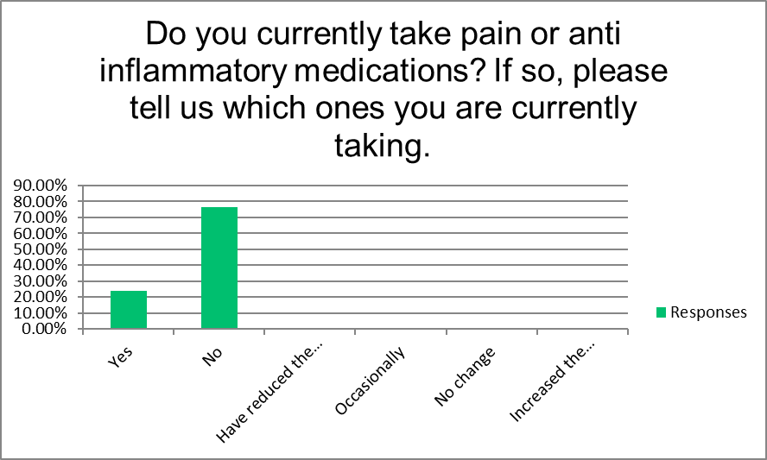

Fig. 10

After using WBV 10.53 % of respondents stopped using pain medications, and another 10.53% or reduced to less powerful medications or reduced the amount. Majority of participant, 50% never took any pain medications. Fig 11 & Table 5

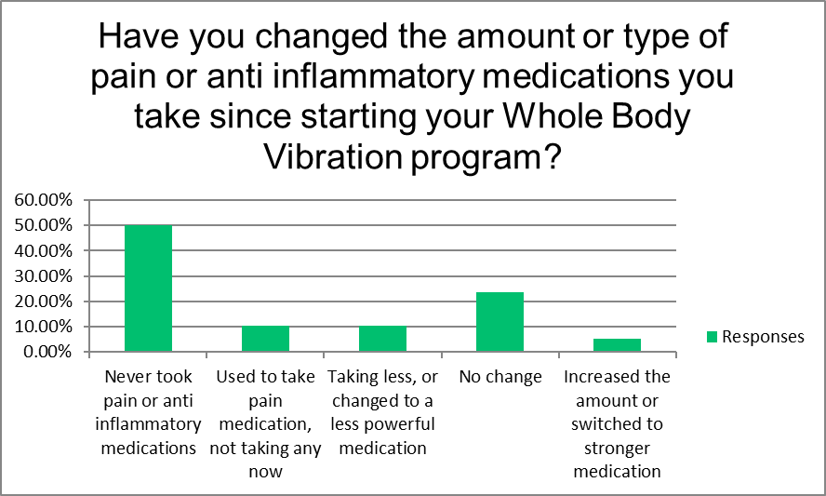

Fig. 11

|  |  |  |
| --- | --- | --- |
| Whole Body Vibration Survey |  |  |
| Have you changed the amount or type of pain or anti-inflammatory medications you take since starting your Whole Body Vibration program? | | |
| Answer Choices |  | |
| Never took pain or anti-inflammatory medications | 50.00% | 19 |
| Used to take pain medication, not taking any now | 10.53% | 4 |
| Taking less, or changed to a less powerful medication | 10.53% | 4 |
| No change | 23.68% | 9 |
| Increased the amount or switched to stronger medication | 5.26% | 2 |

Table 5

WBV was particularly effective in improving Muscle pain/Soreness (43.59% of respondents who had pain that improved with WBV), and Joint pain other than Back pain (33.33%). The least pain improvements were seen in Headaches and Abdominal pain/discomfort, 5.13% each. Fig. 12 & Table 6.

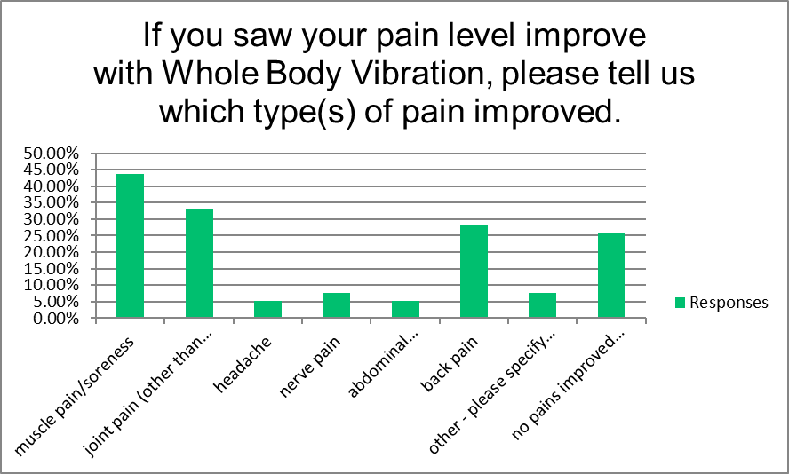

Fig. 12

|  |  |  |
| --- | --- | --- |
| **If you saw your pain level improve with Whole Body Vibration, please tell us which type(s) of pain improved.** | | |
| Answer Choices | Responses | |
| muscle pain/soreness | 43.59% | 17 |
| joint pain (other than back pain) | 33.33% | 13 |
| headache | 5.13% | 2 |
| nerve pain | 7.69% | 3 |
| abdominal pain/discomfort | 5.13% | 2 |
| back pain | 28.21% | 11 |
| other - please specify in box below | 7.69% | 3 |
| no pains improved with WBV | 25.64% | 10 |
|  |  |  |

Table 6

Thirty-nine respondents reported having muscle, joint, back, or nerve pain when they started vibrating (many respondent reported more than one type of pain). Of these respondents, 74% (29) reported an average drop in pain levels of 52% within a few months of beginning WBV. Muscle pain dropped from

Participant whose pain improved reported Muscle pain (17 respondents) before and after starting WBV reported improvement in weighted average from 5 to 2.33 in pain level, a total improvement of 53.4%. Fig. 13

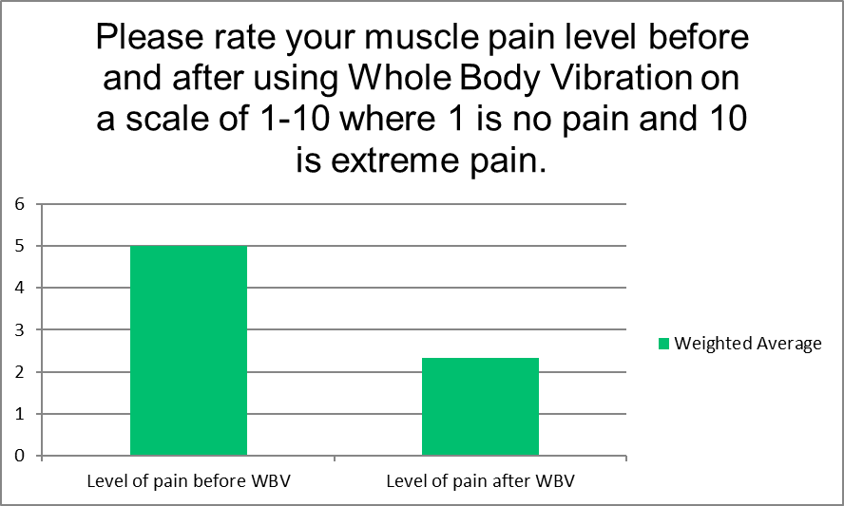

Fig. 13

Fifteen out of 17 respondents (80%) with muscle pain that improved, saw improvement within a few WBV sessions (60% + 20%). Of note is that 20% saw improvement immediately after first session. Fig. 14, table 7.

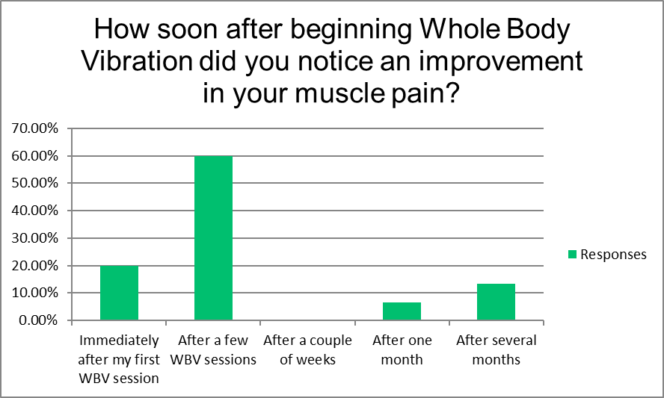

Fig. 14



Table 7

For those whose joint pain improved, the majority (75%) reported knee pain improvement. Those with hip pain and shoulder pain also reported improvements, 33.33% and 41.67%, respectively, as did those with elbow and wrist pain, 25% each. Fig. 15 & table 8.

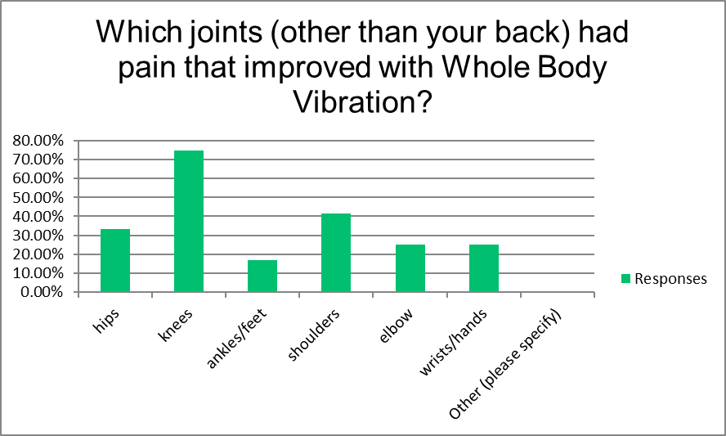

Fig 15



Table 8

For those who reported improvements in Joint pain, the weighted average pain went from 5.33 before WBV, to 2.75 after WBV, a reduction in Joint pain of 51.60%. A reduction in the number of respondents experiencing Joint pain was seen from pain level “4” to level “10”, while more people had lower pain levels after WBV. Fig.16 and table 9

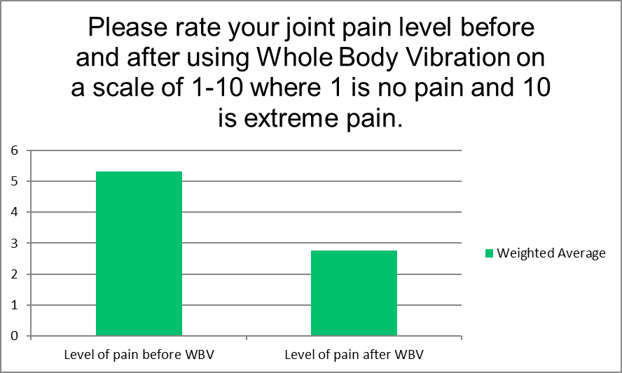

Fig. 16



Table 9

Joint pain improvement was noticed by 63.64% of those whose joint pain improved (54.55% + 9.09%) after few WBV sessions. 100% of those who improved noticed this improvement by several months. Fig. 17 and Table 10.

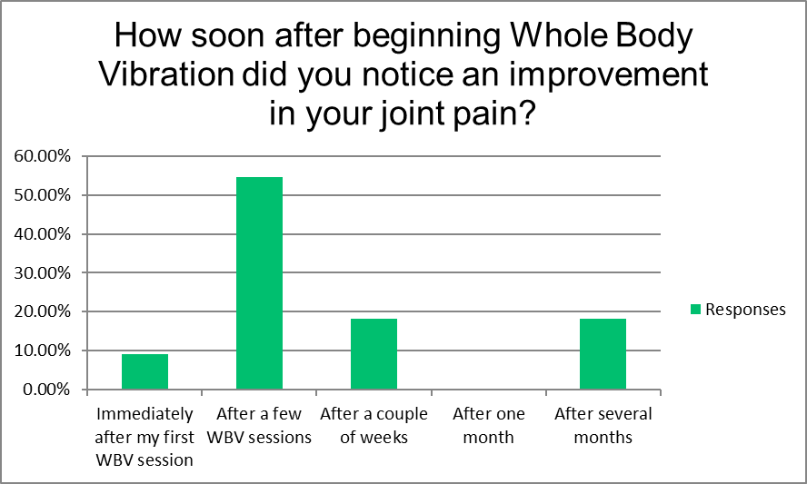

Fig. 17



Table 10

Eleven respondent who had back pain reported improvement in pain. The majority (9) had lower back pain (81.82%) while 5 reported Upper and Mid back pain. A few respondents had multiple areas of back pain which improved. Fig. 18 & table 11

Fig. 18



Table 11

Back pain improvement was noted by weighted average being reduced from 4.64 to 2.09 a reduction in pain by 45.04%. Fig. 19

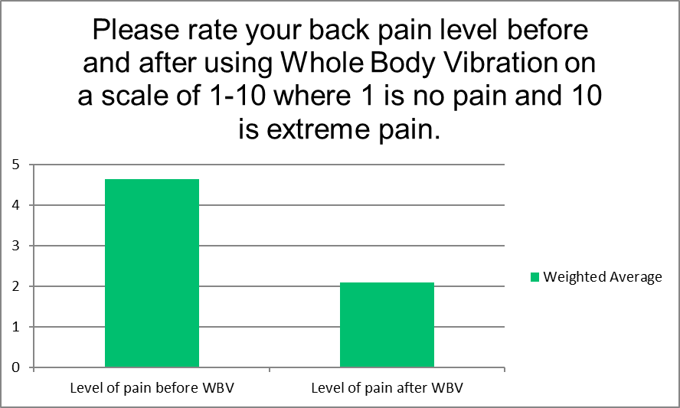

Fig. 19

Of those who responded (11), Majority had improved 27.27% immediately and similar percentage after 1 month (27.27%). In general, improvement was noticed during all time periods. Fig.20 & Table 12

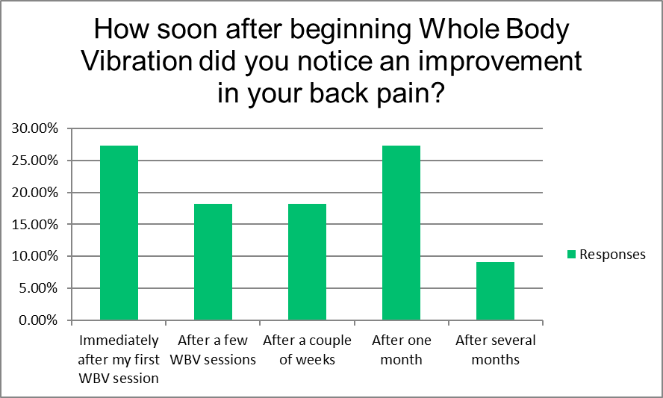

Fig. 20



Table 12

Three people reported Nerve pain improvements, the weighted average pain went from 7.33 before WBV, to 4 after WBV, a reduction in nerve pain of 54.79%.



Of the three respondents who noticed an improvement in nerve pain, 1 (33.3%) noticed this improvement immediately. The other two respondents noticed nerve pain improvement after a couple of weeks.11). Fig.? & Table ?



|  |
| --- |
| **Weight Loss** |
| The respondents were asked about their desire to lose weight. Of the 43 respondents who answered: 51.16% desired weight loss while 48.84% said they did not. Fig. 21 & Table 15.    Fig. 21 |
| Table 15  For the 21 respondents who wanted to lose weight, and also told us how much weight they lost or gained, a total of 47.61% succeeded. The majority of them (33.33%) losing 1 to 20 pounds, and 14.28% losing 20 or more pounds. 9.53% gained 1-10 pounds. Fig 22, Table 16.    Fig 22 |
|  |



Table 16

Of the respondents who lost weight, 100% felt that WBV helped them, with answers ranging from “A little,” to “Moderately,” to “A great deal.” Of those who did not lose weight or gained weight, 2 respondents still felt that WBV had helped them with weight control. Fig. 23, Table 17.



Fig. 23



Table 17

Virtually all of the respondents were not taking weight loss supplements or medications – only 2.27% reported that they did take such products or medications. Fig 24, Table 18.

Fig 24

|  |  |  |  |  |  |  |
| --- | --- | --- | --- | --- | --- | --- |
| **Have you taken weight loss medications or supplements while using Whole Body Vibration? If so, please tell us which ones.** | | | | | | |
| Answer Choices | Responses | |  |  |  |  |
| Regularly | 2.27% | 1 |  |  |  |  |
| Occasionally | 0.00% | 0 |  |  |  |  |
| Never | 70.45% | 31 |  |  |  |  |
| N/A | 29.55% | 13 |  |  |  |  |
| Weight loss medications and/or supplements: |  | 1 |  |  |  |  |
|  | **Answered** | **44** |  |  |  |  |

Table 18

The participants were on following diet regimens and reported to be otherwise healthy:

|  |  |  |  |  |  |  |  |  |  |  |  |  |
| --- | --- | --- | --- | --- | --- | --- | --- | --- | --- | --- | --- | --- |
| Regular diet. No restrictions. | | |  |  |  |  |  |  |  |  |  |  |
| Doing the Keto Diet | |  |  |  |  |  |  |  |  |  |  |  |
| low fat low carb | |  |  |  |  |  |  |  |  |  |  |  |
| I eat whole, healthy foods 3x per day. | | | |  |  |  |  |  |  |  |  |  |
| Avoid fast food and sugar, rarely drink alcohol | | | | |  |  |  |  |  |  |  |  |
| Clean and healthy flexitarian | | |  |  |  |  |  |  |  |  |  |  |
| Balanced |  |  |  |  |  |  |  |  |  |  |  |  |
| Raw fruits and vegetables | | |  |  |  |  |  |  |  |  |  |  |
| Primarily vegetarian. Eat fish two or three times per month. Occasionally eat meat. | | | | | | | |  |  |  |  |  |
| Meat, fish, chicken, salads, veggies, carbs, dessert | | | | |  |  |  |  |  |  |  |  |
| Try not to eat many carbs | | |  |  |  |  |  |  |  |  |  |  |
| Fresh vegetables & fruit; seafood; red meats consist of yak, bison, ostrich, whole grains, yogurt (home-made), some dairy | | | | | | | | | | | |  |
| Healthy paleo | |  |  |  |  |  |  |  |  |  |  |  |
| regular |  |  |  |  |  |  |  |  |  |  |  |  |
| Very low carb, Paleo/Mediterranean type. | | | |  |  |  |  |  |  |  |  |  |
| Good |  |  |  |  |  |  |  |  |  |  |  |  |
| Healthy food choices with moderation due to heavy travel | | | | | |  |  |  |  |  |  |  |
| very healthy with organic fruits and veggies and grass fed/wild caught protein sources | | | | | | | | |  |  |  |  |
| keto |  |  |  |  |  |  |  |  |  |  |  |  |
| Plant Based, low sugar | |  |  |  |  |  |  |  |  |  |  |  |
| Protein shake and a meal bar 3 times a day. | | | |  |  |  |  |  |  |  |  |  |
| Optavia meals | |  |  |  |  |  |  |  |  |  |  |  |
| Close to the "Mediterranean" diet | | |  |  |  |  |  |  |  |  |  |  |
| I do not drink milk and eat meat, suggar and wheat flour. | | | | | |  |  |  |  |  |  |  |
| Mostly plant based. No sugar, flour. | | | |  |  |  |  |  |  |  |  |  |
| Low carbohydrate. | |  |  |  |  |  |  |  |  |  |  |  |
| Paleo ish |  |  |  |  |  |  |  |  |  |  |  |  |
| Meat and fish once a week, otherwise veggies. No junk food. No alcohol. Some sweets. No sodas. | | | | | | | | | |  |  |  |
| mostly plant based, lots of non-starchy vegs with protein, whole food fats. avoid processed foods, sugar, grains | | | | | | | | | | |  |  |
| “Whole 30” Plan | |  |  |  |  |  |  |  |  |  |  |  |
| Eat organic when I can. Try to each a healthy diet as much as possible | | | | | | |  |  |  |  |  |  |
| plant based vegetarian | |  |  |  |  |  |  |  |  |  |  |  |
| Paleo/hunter/gather  Low animal protein | | | |  |  |  |  |  |  |  |  |  |
| ketogenic |  |  |  |  |  |  |  |  |  |  |  |  |
| Changed to Keto like diet. Exercise intensity using vibrator probably has had the biggest impact. | | | | | | | | | |  |  |  |
| Low carb, High protein, vegetables, and quality fat-rich foods. | | | | | |  |  |  |  |  |  |  |
| Eat 1 ingredient foods mainly. Meats, Veges, Fruit, . Have to stay off sugar, causes major inflammation instantly. | | | | | | | | | | |  |  |

85.71% did not change their diet pattern. Fig. 25

Fig. 25

The amount of other types of exercise (besides the WBV) did not significantly change from before using WBV to after using WBV. Figs. 26 & 27, Tables 19 & 20.



Fig. 26 Before WBV



Fig. 27 After WBV



Table 19 Before WBV



Table 20 After WBV

The majority (60%) of respondents who answered the bone density question selected Not Applicable (N/A). Another 27.5% reported no change in their Bone density, and 12.5% said that their bone density was either “significantly” or “a little” better. Fig. 28 & Table 21

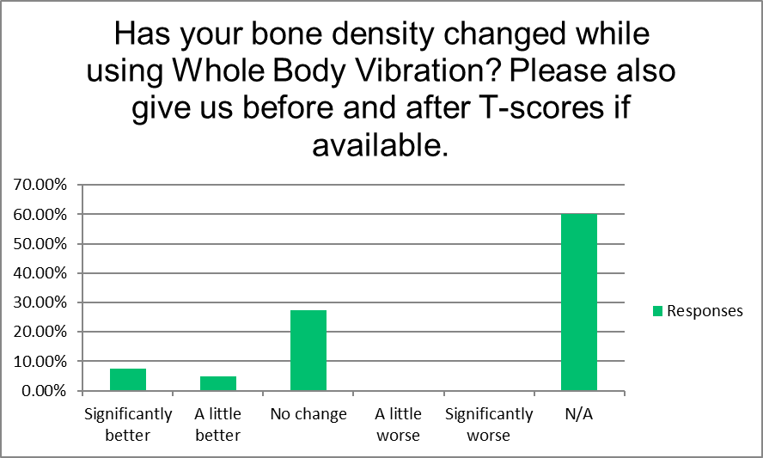

Fig 28



Table 21

Majority (72.50%) were using additional supplements. Figure 29 Table 22 and subsequent responds.

Fig. 29



Table 22

|  |  |  |  |  |  |  |  |  |  |  |
| --- | --- | --- | --- | --- | --- | --- | --- | --- | --- | --- |
| Please describe/specify supplements: | Tags |  |  |  |  |  |  |  |  |  |
|  |  |  |  |  |  |  |  |  |  |  |
|  |  |  |  |  |  |  |  |  |  |  |
| Vitamin c, magnesium, multi-vitamin, calcium lactate, b vitamins, D3 & K2-MK7. | | | | |  |  |  |  |  |  |
| Dr Al Sears: Omega Rejuvenol, Ultra Accel II, Focus IQ, heart tonic. Dr Gundry: Total Restore, Vital Reds. vit D, vit C, MSM | | | | | | | | | |  |
| Multi vitamins + |  |  |  |  |  |  |  |  |  |  |
| Calcium |  |  |  |  |  |  |  |  |  |  |
| Botanical and homeopathics o |  |  |  |  |  |  |  |  |  |  |
| B vitamins, magnesium |  |  |  |  |  |  |  |  |  |  |
| A-D-K; turmeric, cranberry tablets, glucosamine, alpha lipoic acid | | | |  |  |  |  |  |  |  |
| Don’t feel like |  |  |  |  |  |  |  |  |  |  |
| From Dr Al Sears: Ultra Accel II (like CoQ10), Heart Tonic, Omega Rejuvenol, Focus IQ. MSN, B-100 Complex, Move Free, vit D3 50mcg (winter), vit C | | | | | | | | | | |
| omega 3  vitamin D3 |  |  |  |  |  |  |  |  |  |  |
| D3, C Spirulina. Auyervedic herbs & teas. LCarnitine, chloroxy, chlorella. HMB, Ubiquitol. Probiotic. Selenium | | | | | | | |  |  |  |
| Vitamins B, C, D, E, Magnesium and multi-vitamin | |  |  |  |  |  |  |  |  |  |
| Aswanganda, D3, Biotin, Ginko, Brain Health, | |  |  |  |  |  |  |  |  |  |
| GNC multivitamin |  |  |  |  |  |  |  |  |  |  |
| Vit. C B . Vegetable and fruit powder. Probiotics. | |  |  |  |  |  |  |  |  |  |
| many |  |  |  |  |  |  |  |  |  |  |
| Supplements to improve memory/prevent Alzheimer’s, and supplements to lower cholesterol. | | | | | | |  |  |  |  |
| b vitamins, vit D, K, magnesium, calcium, circumin | |  |  |  |  |  |  |  |  |  |
| Algae mineral  D3  Botanicals |  |  |  |  |  |  |  |  |  |  |
| Multi Collagen protein powder. |  |  |  |  |  |  |  |  |  |  |
| Calcium |  |  |  |  |  |  |  |  |  |  |
| collagen, immunity supplement, vitamin D | |  |  |  |  |  |  |  |  |  |
| Calcium, Magnesium, B12  Twenty-nine responded using following medications:   |  |  |  |  |  |  |  | | --- | --- | --- | --- | --- | --- | --- | | Melatonin |  |  |  |  |  |  | | Thyroid Medications | |  |  |  |  |  | | losarten |  |  |  |  |  |  | | None |  |  |  |  |  |  | | Amlodipine 5mg, Losartan 100mg | | |  |  |  |  | | No |  |  |  |  |  |  | | No |  |  |  |  |  |  | | Wp thyroid |  |  |  |  |  |  | | No |  |  |  |  |  |  | | levothyroxine | |  |  |  |  |  | | —— |  |  |  |  |  |  | | Amlodipine 2.5 mg, Losartan 100mg | | | |  |  |  | | blood thinner | |  |  |  |  |  | | Hydrocodone | |  |  |  |  |  | | No |  |  |  |  |  |  | | Synthroid |  |  |  |  |  |  | | No |  |  |  |  |  |  | | No. |  |  |  |  |  |  | | 50mg Viagra as needed, 25 mcg Levothyroxine every morning. | | | | | |  | | levothyroxine, finasteride, eye drops | | | |  |  |  | | X |  |  |  |  |  |  | | none |  |  |  |  |  |  | | no |  |  |  |  |  |  | | No |  |  |  |  |  |  | | Propafenone, 225 MG 3x/day | | |  |  |  |  | | Lamictal |  |  |  |  |  |  | | mirbetrix |  |  |  |  |  |  | | None  Synthroid |  |  |  |  |  |  | | 82.50% either did not consumed alcohol or very little. Fig. 30 & Table 23 |  |  |  |  |  |  | |  |  |  |  |  |  |  |  |  |  |
|  |  |  |  |  |  |  |  |  |  |  |

Fig. 30

|  |  |  |  |
| --- | --- | --- | --- |
| A great deal | 0.00% | 0 |  |
| A lot | 0.00% | 0 |  |
| A moderate amount | 17.50% | 7 |  |
| A little | 40.00% | 16 |  |
| None at all | 42.50% | 17 |  |
| Comments: |  | 6 |  |
|  | **Answered** | **40** |  |

Table 23

Thirty-eight respondent reported 100% one of them were non-smoker. Fig. 31

Fig. 31

Majority (97.5%) did not use recreational drugs. Fig. 32

Fig. 32

Majority of respondents (40%) used WBV 2-4 times a week, and 32.50% used it daily, for a combined total of 72.50% using it 2 or more times per week. Fig. 33 & table 24

Fig. 33

|  |  |  |  |
| --- | --- | --- | --- |
| **How often do you use your Power 1000 machine?** | | | |
| Answer Choices | Responses | |  |
| Daily | 32.50% | 13 |  |
| 2-4 times per week | 40.00% | 16 |  |
| Once a week | 7.50% | 3 |  |
| Occasionally | 5.00% | 2 |  |
| Intermittently | 12.50% | 5 |  |
| Never | 2.50% | 1 |  |
|  | **Answered** | **40** |  |

Table 24

Fig. 34 and Table 25 shows how participants began WBV Power 1000

Fig. 34



Table 25

Fifty-five percent of respondents began their WBV program slowly and then slowly built up the time and frequency. Some were following the directions in the manual, 4 respondents commented that they had adverse reactions if they tried to increase rapidly. Figure 35, Table 26

Fig. 35

|  |  |  |  |  |  |  |
| --- | --- | --- | --- | --- | --- | --- |
| Answer Choices | Responses | | | | | |
| Yes | 55.00% | | | | | 22 |
| No | 45.00% | | | | | 18 |
| If yes, please tell us why: |  | | | | | 16 |
|  | **Responses:** | | | | |  |
|  |  | | | | |  |
| My chiropractor recommended to start slowly and build up | | | | |  | |  |  |  |  |
| for my body to adjust. Otherwise I would get a headache and neck pain. | | | | | | |  |  |  |  |
| I did build up slowly with no negative results. | | | |  |  | |  |  |  |  |
| Directions said to | |  |  |  |  | |  |  |  |  |
| Unsure | |  |  |  |  | |  |  |  |  |
| I wanted to see how it worked. I wanted to build on my progress without overdoing and having  to stop for a time. | | | | | | | | | | |
| Being careful | |  |  |  |  | |  |  |  |  |
| To give time for the body to adapt. | | |  |  |  | |  |  |  |  |
| Don't know for sure. | |  |  |  |  | |  |  |  |  |
| Wanted to get accustom to it. | | |  |  |  | |  |  |  |  |
| Got sore | |  |  |  |  | |  |  |  |  |
| Learned from experience to go slowly | | |  |  |  | |  |  |  |  |
| I wasn't sure it was needed, but my wife was very appreciative of the graduated start. | | | | | | | | |  |  |
| To slowly detox - I had some skin reactions due to increase of intensity of use at the beginning. | | | | | | | | | |  |
| You told me to | |  |  |  |  | |  |  |  |  |
| That is what I was instructed to do and told the reasons why.  Table 26  *When inquired regarding problems the following responses were obtained:*  No  Yes I returned it and got a new machine.  no  NONE  No  No  No  No  It stopped working December 2018, but was replaced. Great customer support. Thanks Becky! :)  No  no  no--adapted very quickly  No  No  No  no  No  No.  No  No.  No  No.  No  no  No  no  Sometimes aggravates my neck  "Can’t go over 30  Prefer 27-28  I’m underweight for my height"  no  None  Just some bumps 7 of them on my skin. My Chiropractor said it was because I was detoxing with WBV too fast.  When I use it, I find it reactivates concussion symptoms from a car accident, though initially it felt very energizing. I had to stop using it. I called to ask about returning it and was told that because it was just after a month of purchase, nothing could be done (even though it took over a week to arrive). So I have a $ 1,000, basically unused machine in my basement (that it took me over a year to save up for) I recently tried it again, after a year, and had the same problem with my head, only quicker. [Note: Vibrant Health tried numerous times to contact this person to resolve this problem, with no success]  It may make my ankle (sprained 2 year ago) a little more noticeable, and my knee isn't getting better since using it. I wonder if it exacerbates it...  no  No  No | | | | | | |  |  |  |  |

|  |  |  |  |  |  |
| --- | --- | --- | --- | --- | --- |
| Responses obtained for question **Do you have any other comments you would like to make?** | | | | | |
| **Answered** | **30** |  |  |  |  |

|  |  |  |  |  |  |  |  |  |  |  |  |  |  |  |  |  |
| --- | --- | --- | --- | --- | --- | --- | --- | --- | --- | --- | --- | --- | --- | --- | --- | --- |
| Not at this time. | |  |  |  |  |  |  |  |  |  |  |  |  |  |  |  |
| I love the muscle strength and increased mood it has provided | | | | | |  |  |  |  |  |  |  |  |  |  |  |
| I feel that it was a wise investment. | | |  |  |  |  |  |  |  |  |  |  |  |  |  |  |
| Noticed an increase in my upper body mussel development. Did not experience any detox issues. I do 5 minutes just standing then 1 minute each on 5 exercise positions. | | | | | | | | | | | | | | | | |
| I love the gentle, deep massage feeling the machine provides. It is very relaxing, and I love doing qigong on my platform. | | | | | | | | | | | |  |  |  |  |  |
| Love it. I like to do the exercises on it | | | |  |  |  |  |  |  |  |  |  |  |  |  |  |
| Great product. My girlfriend and I use it for 5 minutes twice a day while brushing our teeth. :) | | | | | | | | |  |  |  |  |  |  |  |  |
| Just that it is the easiest thing to do and get results.  I always feel like I am doing something good every time I use it. | | | | | | | | | | | |  |  |  |  |  |
| The most obvious response I have experienced is increased energy! | | | | | | |  |  |  |  |  |  |  |  |  |  |
| Kinda to long with wanting me to list medications, food, and etc | | | | | |  |  |  |  |  |  |  |  |  |  |  |
| I believe this machine to be the missing piece to my health recovery. Exercise/mobility is vital to quality of life. I want to live, not exist. | | | | | | | | | | | | |  |  |  |  |
| no |  |  |  |  |  |  |  |  |  |  |  |  |  |  |  |  |
| No |  |  |  |  |  |  |  |  |  |  |  |  |  |  |  |  |
| Not much help from it. I will sell it at my next garage sale. | | | | | |  |  |  |  |  |  |  |  |  |  |  |
| Since I used the vibration machine for such a short time, I'm not sure my input will be useful for your study. | | | | | | | | | | |  |  |  |  |  |  |
| I really recommend its use to improve your health and quality of life. | | | | | | |  |  |  |  |  |  |  |  |  |  |
| I wish I had the discipline to use it regularly. I hope it would improve my balance more. | | | | | | | | |  |  |  |  |  |  |  |  |
| I need more and better instructions on how to properly use the machine. | | | | | | |  |  |  |  |  |  |  |  |  |  |
| Great investment - really helps me and my grandkids love it too! | | | | | |  |  |  |  |  |  |  |  |  |  |  |
| Have slacked off, but may be able to pick it back up. | | | | |  |  |  |  |  |  |  |  |  |  |  |  |
| Much prefer my VibePlate. Variable speeds without a time limit. Larger surface to work on. | | | | | | | | |  |  |  |  |  |  |  |  |
| Not at this time. But would like something more than the poster. I have used programs from other companies and it helps to get a well rounded program. | | | | | | | | | | | | | | |  |  |
| Love it |  |  |  |  |  |  |  |  |  |  |  |  |  |  |  |  |
| I been able to increase to 50 deep knee squats in 5 minutes which is my favorite workout on the platform   This has increased my resilience climbing hills | | | | | | | | | | | | | | | |  |
| I need to start using it daily. I have gotten away from my routine. | | | | | |  |  |  |  |  |  |  |  |  |  |  |

**Discussion**

WBV is currently being used in a wide range of settings, from personally owned machines used at home, to gyms, health spas, sports franchises, physical therapy centers, hospitals, and weight loss clinics. There are also a wide range of types of WBV machines and suggested methods of use are available in this country for the general public, with variable results and numerous anecdotal claims. The purpose of this Retrospective Observational study is to assess if there are benefits of WBV using the Vibrant Health Power 1000 (VH Power 1000) vibration machine for relatively healthy people who want to improve quality of life health issues (i.e. strength, energy level, mobility, sleep, mood/anxiety level, and pain levels). There are other machines with a similar type of vibration, but they are either considerably more expensive, very inexpensive and of inferior quality, or designed primarily for intensive exercise with less flexibility for those with health issues. Our machine is designed to be an economical and safe way to improve the health of both the mind and body.

Baby boomers, or people over age 50, compromise the majority of people buying the VH Power 1000 vibration machine (90%). This population tends to be highly motivated to improve their health, as they start to feel the effects of age with increased joint and muscle pain and disability. According to self-assessment the respondents in this study are quite successful in their quest to maintain and improve their health with about 80% of respondents rating themselves in average to excellent health, and eating a healthy diet.

A little more than half of the respondents were women, perhaps reflecting women’s greater concern and attention to their health, but men were well represented as well. About half of the respondents had their VH Power machine for one to two years, and most of the rest for 1-12 months. This time frame gives a good opportunity to look at the effects of the WBV. It is significant that more than 75% of the respondents had never used WBV before or only occasionally, as we particularly wanted to look at the effects of this type of vibration.

Twenty-eight percent of survey recipients responded to the survey, with 98% of participants responding within one week. This high level of participation and rapid response, even with the majority of participants owning their machine 1-2 years, may indicate a greater level of enthusiasm for WBV than for other types of exercise equipment.

The VH Power 1000 delivers a type of vibration called vertical vibration (aka linear vibration). In this type of vibration, the entire platform rapidly moves in the same direction – vertically up and down. This is distinctly different than oscillation vibration machines, in which one side of the platform goes up while the other side is going down, back and forth like a see saw.

With a relatively low maximum amplitude (1.25mm) and correspondingly relatively low maximum g-force (1.85g), the VH Power 1000 creates a motion that feels like the purring of a large cat. This delivers effective, but gentle and safe WBV.

Oscillation vibration machines have maximum amplitudes of up to 10mm, which combined with the rapid seesaw motion, creates a wild motion for the person standing on the vibration plate. Because of the large oscillation these machines run at low frequencies (0-20 Hz).

Vertical vibration machines have a smoother motion so they can have higher frequency settings (25-50 Hz) creating increased benefits without wild motion.

There are also very powerful vertical vibration machines with maximum amplitudes of up to 4-6mm, but these machines were originally developed for Olympic athletes. They create an intense jarring vibration that is too forceful for older persons dealing with age and lifestyle related health issues.

In addition, these very powerful vertical vibration machines create their high amplitude of motion by using two motors at the same time. As desychronized brain waves have been linked to dangerous and poor health states (Dispenza, 2017), and two motors cannot be continuously perfectly synchronized, the VH Power 1000 was developed with only one motor to protects against potential brain wave desynchronization.

Results in this study should be applied only to the use of the VH Power 1000 vibration machine as used with Ms Chambers protocol, outlined earlier in the Methods section. Different types and amounts of vibration can lead to different outcomes. Further study looking at the effects of different types and amounts of vibration would be useful.

There are also quite a few contraindications for WBV use. Absolute Contraindications rule out the use of WBV completely. Conditions listed as Relative Contraindications may sometimes benefit from WBV, but WBV should only be used in these cases with a cautious approach and possibly additional therapies and support.

Osteoporosis with a T-Score of greater than -2.5 is listed as an Absolute Contraindication. However, increasing bone density has been frequently studied and reported with WBV [citations] and is a common motivation for WBV use. Ms. Chambers reports some people using the VHPower 1000 for osteoporosis with T=-scores of up to -3.5 with good results. The VH Power 1000 has a gentler vibration than many machines, which may allow a greater range of use with more fragile people, but it should be used with caution. Based on the anecdotal evidence the VH Power 1000 could possibly be used with people with osteoporosis T-scores of -3.5, but further studies are warranted.

WBV has been shown in previous studies (Bokaeian, 2016), to reduce joint pain, and increase strength and mobility. The majority of respondents to this survey noticed significant improvements for all characteristics looked at: strength, energy, mobility, sleep, and mood/anxiety, and pain levels.

**Strength** is well known to improve rapidly with WBV: Studies have seen this for athletes (Bosco, 2016), non-athletic but healthy people (Delcluse, 2003) and in rehabilitative situations (Stein et al., 2010). In our survey, strength was also reported as increasing, by a weighted average of 25%. Remarkably, 17.65% of participants noticed an increase in their strength after the first few WBV sessions, while a total of 64.71% of respondents had noticed an increase in strength within a few months.

**Energy** levels specifically have not been studied previously with WBV, but with the clear and consistent evidence that strength and athletic performance improve with WBV, it could be inferred that energy levels would probably be also increasing. In our study a total of 69% of respondents reported a weighted average increase of 28% in energy within a few months, with 19.23% noticing greater energy after just a few WBV sessions. With many people in the general public complaining of a lack of energy, this would be an important characteristic to study further.

There was also a weighted average increase in **mobility** of 20% within a few months. Almost 20% noticed their mobility increasing within a few WBV sessions, and by a few months 70.59% of the respondents had noticed an improvement. It makes sense that there was an improvement in mobility, as, at the same time, pain levels were going down, and strength and energy increasing, all characteristics that would have a big impact on mobility.

|  |
| --- |
| **Pain:** In our study Overall pain levels went down 30.87%. Focusing only on those whose pain improved, we observed reductions in pain for several different types of pain, and in numerous areas of the body: Most notably, we saw a 53.4% reduction in muscle pain, 51.6% for joint pain (particularly for knees, hips, and shoulders), and 45% for back pain (mostly lower back). Other researchers have also seen reductions in pain for muscle (Alentorn-Geli, 2008), knee (Bokaeian, 2016), and lower back pain (Zheng, 2019).  Our data showed pain in numerous different joints improving with WBV. Of those participants reporting joint pain improvement, 75% had knee pain, 33.33% hip pain, 41.67% shoulder pain, 25% elbow pain, 25% wrists/hands pain, and 16.67% ankles/feet pain, with improvements often reported in different areas simultaneously by individuals. This sort of systemic effect will be discussed in further detail in the Systemic Effects section below.  The reductions seen in pain levels are particularly striking given that after using WBV 10.53 % of respondents stopped using their pain medications, and another 10.53% either changed to less powerful medications or reduced the amount.  There are indications that WBV could be very effective for nerve pain and function (with a weighted average drop in nerve pain levels of 54.79%), but further study is needed as the sample size was small (3 respondents reporting nerve pain that improved). Two respondents commented on dramatic improvements:  “I am recovering / reversing from Neuropathy. The WBV brought immediate results.”  “My best results - a major decrease in sciatic pain!" |
|  |

One respondent’s data was excluded from our study. Her pain level jumped from a 1 (No Pain) to a 10 (Extreme Pain) but in a follow up phone call is was found that she did not follow the protocol. See below for a discussion of the importance of following the protocol.

Future studies should be done regarding WBV’s effect on nerve pain and function.

Two respondents each also reported improvements for headaches and abdominal pain. Research in these areas would also be helpful.

In our survey **sleep** and **mood/anxiety** levels both improved (17% and 14%), and rapidly (16-18% of respondents reporting improvements after a few sessions and 60% by the end of a few months, for both characteristics). This is possibly due to serotonin levels increasing as both of those characteristics are highly affected by serotonin levels. There has been some early research with animals showing an increase in neurotransmitter levels (serotonin and norepinephrine) with WBV (Ariizumi, 1983). Further research in this area would be very useful.

The **rapidity of change,** andacross many categories, after beginning WBV is evidence that the WBV is producing our results, not some other unconsidered factor. Between 16-20% of the respondents reported noticing an increase in strength, energy, mobility, and improvements in sleep and mood/anxiety within a few sessions of WBV. Within a few months the number reporting improvements in those same characteristics had jumped to 59-70%. Similarly rapid changes have been seen in a study by Bosco (1999) looking at strength improvements after one session of WBV.

Even more striking is the rapidity of response for pain reduction. Twenty percent of respondents reported an improvement in muscle pain after only one WBV session, with a total of 80% reporting improvements after a few WBV sessions. For Joint pains, 9% of respondents reported improvements after one WBV session, with a total of 82% reporting improvements with two weeks. For Back pain, 27% noticed an improvement immediately, a total of 90% by one month. And nerve pain relief was similarly rapid with 33% noticing improvement after one session, and 100% of those feeling nerve pain relief noticing this relief within 2 weeks.

**Systemic Effects:** That pain levels are going down for many joints all around the body seems to indicate that WBV is working in systemic ways to improve health. Other researchers have shown lowered inflammatory markers in mice with a similar protocol of WBV, i.e. regular, short duration, high frequency, low amplitude, vertical WBV (Yin, 2015). Perhaps the WBV is inducing lowered inflammation in our survey population – this would explain, at least partially, the rapid improvement in so many different areas of the body at the same time, from often only a few very short (1-3 minutes long) WBV sessions. Further WBV research looking at inflammation levels in people is needed.

There are several possible effects of WBV that could be contributing to our systemic positive results and possible lowered inflammation levels. WBV increases circulation (as does all exercise) bringing nutrients and oxygen and removing waste products from all tissues. It also increases detoxification by stimulating the lymphatic system with muscle fibers tensing and relaxing around the lymphatic vessels at the same rate the machine is vibrating (26-45Hz).

There is also a powerful stimulation of the nervous system and brain (26-45 times per second all neurons will automatically be firing in response the vibration) possibly leading to systemic benefits. Exercise, which WBV is well understood to provide, is well known in humans to help the brain and nervous system. It has been shown to develop stronger healthier neurons, stimulate the formation of more neural connections, and to increase neurotransmitter levels (Wegner, 2014). A strong, healthy, active brain will modulate and direct the body to heal itself more effectively.

It is also possible that the synchronized and coherent message from the vibration of the VH Power 1000 is helping the brain to move into a synchronized brain wave state. Such synchronized brain wave states have been linked to greater mental and physical health (Dispenza, 2017). This would be an important area to research further. It would also be very interesting to look at what type of wave lengths are produced during WBV. In recent years mediation has come to be accepted as a powerful tool for improving health (Grossman, 2004). Perhaps, like meditation, WBV may help the brain move from the more stressful beta wavelength to the slower, calmer alpha or even theta wavelengths. In these states the conscious mind has greater access to the autonomic nervous system, which controls so much of the body’s functioning.

For example, increases in other beneficial hormones (testosterone and human growth hormone), and a decrease in cortisol, our stress and aging hormone has also been reported (Bosco, 2000). These changes would lead to improved health, and they are controlled by the autonomic nervous system. Further research with WBV into hormone changes would be helpful.

**Following the Protocol**: The best results are achieve using the correct type of vibration, and following a slow and cautious approach as outlined in the Methods section (and in the User’s Manual), especially with people with health issues. Along with WBV’s many beneficial effects, it can also be stressful. This can be seen in the increasing levels of corticosterone with higher amounts of WBV, reported by Ariizumi, 1983. WBV is an intense stimulation of every part of the body. How much WBV is best for a person will depend on how much stress to their body they can easily tolerate – if stress levels increase too fast it may cause inflammation levels to increase rather than decrease. Therefore, for safety and achieving the best results, WBV should be very gradually introduced to fragile, weakened, or otherwise compromised people.

For example, too much detoxification too quickly can lead to an increase rather than a decrease in symptoms. More detoxification that a person’s liver and kidneys can easily handle will stress the liver and kidneys, which can lead to an increase in inflammation levels and symptoms increasing. This is especially true in people who already have stressed detoxification organs (liver & kidneys).

How much WBV is too much can be highly variable between people, depending on the state of their health. Young, healthy people will often have no problem diving right into WBV, i.e. starting out with larger amounts and increasing rapidly. Older people, or those with pre-existing health issues, will likely need to start very slowly and increase slowly.

For example, the person whose data was excluded did not follow the protocol guidelines to start slowly and to not use WBV shortly after surgery, or acute inflammation. A follow-up phone call determined that the second time she used her vibration machine was for 5 minutes, 5 days after dental surgery to remove an implant post, surgery she described as, “the most excruciating experience of my life.” Her pain level increased dramatically (from no pain to extreme pain overnight before dropping again to no pain the day after that), but it is a contraindication to use WBV shortly after surgery and/or when there is acute inflammation, which pain described as “the most excruciating experience of my life” would indicate. Also she is in her 70’s, so it is especially important to start WBV slowly (30 seconds to 1 minute the first time, one to two minutes the second time, and so on). In this case, it appears that the nerves in this woman’s face and jaw were still highly irritated, so the intense stimulation of 5 minutes of WBV caused her pain to briefly flare up again.

The variability in response depending on an individual’s health status may account for some of the conflicting results seen in WBV research. For example we have cited two studies in this paper, one showing increasing corticosterone levels (Ariizumi, 1983), and the other decreasing cortisol (Bosco, 2000). Both may, in fact, be true depending on differing circumstances. It is important to control for, and usually not taken into account, that are the many different types WBV, including the type of motion, amplitude and g force, and frequency (Cerciello, 2016). All these factors can play a critical role in the results, and these factors especially increase in importance with older, debilitated, and otherwise more fragile people – populations which are often the focus of WBV research studies.

**Weight Loss:** WBV has previously been reported to aid in weight loss (Vissers, 2010). In our study, about half (47.83%) of the 23 respondents who wanted to lose weight did lose weight over the two year period our study covered (5 lost 1-10lbs, 3 lost 10-20lbs, 1 lost 20-30lbs, and 2 lost 30+ lbs). Eight others (34.78%) saw no change, and only 2 (8.7%) gained any weight (1-10 lbs). The majority of respondents (54.7%) had their vibration machine for over a year, another 20.75% for 6-12 months, so we can consider our results an indication that these respondents were able to also maintain their weight loss.

When you factor in how difficult it is for older people to lose weight, and compare our weight loss results to the generally poor success rate for people losing and maintaining weight loss, it appears that WBV could be a significant aid to losing weight. Quite a few of the respondents who lost weight (60.87%), said that they think that WBV helped them: 3 selected “a great deal,” 1 “a lot,” 4 “a moderate amount,” and 6 answered “a little.”

None of our respondents reported using weight loss medications or natural weight loss products, so this is not a factor. Many of the respondents were eating a generally healthy and weight-loss promoting diet (self-reported), low in processed foods and carbohydrates, but the success rate of weight loss programs including maintaining a weight loss using diet alone is much lower (sometimes reported at 15%) than our 50% reported success rate.

Certainly, WBV is exercise, and as with all exercise this would increases metabolism increasing calories burned, both during the actual exercise session and with increased metabolism for the entire day as well.

But if there is an actual an increase in serotonin levels, as indicated by our rapidly improving mood and sleep results, this would likely improve weight loss success also. Increased serotonin is associated with increased motivation, focus, confidence, and activity levels. All of these effects would help a person in the difficult endeavors of losing weight and changing their lifestyle.

Further controlled studies using the proper type and method of WBV, combined with good nutrition and aerobic exercise, might give even better results for weight loss. WBV is similar to conventional weight-lifting for increasing muscle strength (though with faster results: 10-15 minutes WBV = one hour of conventional weight lifting), but WBV is not effective cardiovascular exercise, so adding cardiovascular exercise to a WBV program is recommended.

**Bone Density:**

Osteoporosis is a common motivation for people using WBV, and there has been research reporting significant increases in bone density with WBV (Thompson, 2014). However, our survey did not cover a long enough time period to look thoroughly at bone density changes. For the general public bone density tests are only done every three years. This likely three year testing period for most respondents, combined with our study time frame of only 2 years, meant most respondents could not answer the question about bone density change.

The majority of our survey respondents were menopausal women and older men, populations that typically are at risk for and concerned with osteoporosis. And though many had bought the machine hoping for an increase in bone density (as related in conversation or email at the time of purchase), 60% answered N/A (Not Applicable) to our survey question, “Has your bone density changed while using whole body vibration?”

However, despite the limitations in gathering data on bone density, 12.5% of the respondents who answered this question did tell us that their bone density had improved either “significantly” or “a little.” We also had zero respondents reporting that their bone density decreased – this is a potentially very good sign, as most our respondents are either at risk for, already have osteopenia/osteoporosis and were concerned about bone loss. In fact, one person who stopped taking Boniva when she got her machine one year earlier, commented, “I ‘held my own’ without medication, which was GREAT! That's why I bought the machine.”

And bone density tests done in the first year or two might not have enough time to reflect the effect of the WBV, as for during the 1-2 years before starting WBV the person would likely have still been experiencing bone loss. Considering that 50% of our respondents had their machine for 1 -2 years, and bone density tests are usually done every three years, only 16.67% (½ x 1/3 = 1/6) of our respondents would be expected to be able to answer the bone density question accurately.

We had 12.5% of respondents to the bone density question reporting an improvement… possibly up to three quarters (12.5/16.67) of our survey respondents with a bone density issue are in the process of increasing their bone density. If so, this would be an extremely positive result, better in fact, than most WBV bone density studies have so far reported. This might be because our population is overall a highly health conscious and proactive group who were also mostly following a good diet, in relatively good health, and taking a wide range of nutritional supplements including good bone building supplement regimes. We will follow up with the participants of this study in the next few years to get a more accurate picture of the bone density effects.

In conclusion, our results indicate numerous potential benefits of WBV using the VH Power 1000 machine with Ms. Chambers’ protocol, especially in relatively healthy women and men ages 50-90. Based on our survey data, we would like to conduct further clinical research to investigate these different areas in controlled situations.

**Conclusion**

Our results showed that WBV with the VH Power 1000 machine using a slow and careful approach leads to rapid and significant improvements in strength, energy, mobility, sleep, mood/anxiety, and pain levels for the majority of users. There was also some improvement in weight loss, and possibly in bone density, but our study was not long enough to fully assess the bone density effects. The many functions and areas of the body in which we observed improvements leads up to feel that there must be systemic effects, but those could not be determined in this type of retrospective observational survey. Clinical trials are recommended in all the areas studied to confirm the results and to explore the mechanism(s) of improvement.

**References**

# [Alentorn-Geli E](https://www.ncbi.nlm.nih.gov/pubmed/?term=Alentorn-Geli%20E%5BAuthor%5D&cauthor=true&cauthor_uid=18990045). et al., Six weeks of whole-body vibration exercise improves pain and fatigue in women with fibromyalgia. [J Altern Complement Med.](https://www.ncbi.nlm.nih.gov/pubmed/18990045?dopt=Abstract) 2008 Oct;14(8):975-81. doi: 10.1089/acm.2008.0050.

Anwer, S., et al. Effect of whole body vibration training on quadriceps muscle strength in individuals with knee osteoarthritis: a systematic review and meta-analysis. Physiotherapy 102 (2016) 145–151

Ariizumi, M., Okada, A. Effect of whole body vibration on the rat brain content of serotonin and plasma corticosterone. Eur J Appl Physiol Occup Physiol. 1983;52(1):15-9.

Bokaeian, H., et al. The effect of adding whole body vibration training to strengthening training in the treatment of knee osteoarthritis: A randomized clinical trial. Journal of Bodywork & Movement Therapies (2016) 20, 334e340.

Bosco C, et al.: Hormonal Responses to Whole Body Vibration in men. Eur J Appl Physiol. 2000, 449-454.

Bosco, C., et al. Adaptive responses of human skeletal muscle to vibration exposure. Physiotherapy 102 (2016) 145–151.

Cerciello, S., et al., Clinical applications of vibration therapy in orthopaedic practice. [Muscles Ligaments Tendons J](https://www.ncbi.nlm.nih.gov/pmc/articles/PMC4915454/). 2016 Jan-Mar; 6(1): 147–156.

da Silva, V. F., et al. Stimulation by Light and Sound: Therapeutics Effects in Humans: Systematic Review. *Clinical Practice and Epidemiology in Mental Health* 11 (June 26, 2015): 150–54. doi:10.2174/1745017901511010150.

DELECLUSE, C., M. ROELANTS, and S. VERSCHUEREN. Strength Increase after Whole-Body Vibration Compared with Resistance Training. Med. Sci. Sports Exerc., Vol. 35, No. 6, pp. 1033-1041, 2003.

Dispenza, J. *Becoming Supernatural: How common People Are Doing the Uncommon.* Carlsbad, CA: Hay House, Inc. 2017

Fanous, S., What Is Vibration Therapy? Medically reviewed by [University of Illinois-Chicago, School of Medicine](https://www.healthline.com/medical-team) on July 19, 2016. <https://www.healthline.com/health/vibration-therapy>

# [Gilsanz V](https://www.ncbi.nlm.nih.gov/pubmed/?term=Gilsanz%20V%5BAuthor%5D&cauthor=true&cauthor_uid=16939405)., Low-level, high-frequency mechanical signals enhance musculoskeletal development of young women with low BMD. [J Bone Miner Res.](https://www.ncbi.nlm.nih.gov/pubmed/16939405?dopt=AbstractPlus) 2006 Sep;21(9):1464-74.

Grossman P, et al. Mindfulness-based stress reduction and health benefits: a meta-analysis.From book found on NCBI website: Database of Abstracts of Reviews of Effects (DARE): Quality-assessed Reviews [Internet], 2004.

Iwamoto, J., et al., Effect of Whole-Body Vibration Exercise on Lumbar Bone Mineral Density, Bone Turnover, and Chronic Back Pain in Post-Menopausal Osteoporotic Women Treated with Alendronate, *Aging Clin Exp Res* 17, no. 2 (April 2005): 157–63.

Stein, G., 2010. Whole body vibration compared to conventional physiotherapy in patients with

gonarthrosis: a protocol for a randomized, controlled study. BMC Musculoskelet. Disord. 11, 128.

## Thompson, WR, et al., Vibration therapy: clinical applications in bone. **Review article,** Curr Opin Endocrinol Diabetes Obes. 2014.

Vissers, D., et al., Effect of Long-Term Whole Body Vibration Training

on Visceral Adipose Tissue: A Preliminary Report. *Obes Facts* 3, no. 2

(2010): 93–100.

Yin, H., *et al.* Whole body vibration therapy: a novel

potential treatment for type 2 diabetes mellitus. *SpringerPlus (2015) 4:578.*

[Wegner M](https://www.ncbi.nlm.nih.gov/pubmed/?term=Wegner%20M%5BAuthor%5D&cauthor=true&cauthor_uid=24923346), et al.,Effects of exercise on anxiety and depression disorders: review of meta- analyses and neurobiological mechanisms.[CNS Neurol Disord Drug Targets.](https://www.ncbi.nlm.nih.gov/pubmed/24923346) 2014;13(6):1002-14.

Zheng, Y., Wang, X., Chen, B., Gu, W., Wang, X., Xu, B., . . . Wang, X. (2019). Effect of 12-Week Whole-Body Vibration Exercise on Lumbopelvic Proprioception and Pain Control in Young Adults with Nonspecific Low Back Pain. *Medical Science Monitor,* *25*, 443-452. doi:10.12659/msm.912047